Supplementary material

Supplementary material 1. STROBE reporting cross-reference
Item | Reporting topic | Location in manuscript
1 | Title and abstract | Title; structured Abstract
2 | Background/rationale | Section 1. Introduction
3 | Objectives/hypotheses | Section 1, final paragraph
4 | Study design | Section 2.1
5 | Setting and dates | Sections 2.1 and 2.9
6 | Participants/eligibility | Section 2.3; Fig. 1
7 | Variables/exposure/outcomes/confounders | Sections 2.4–2.6
8 | Data sources and measurement | Sections 2.7–2.10
9 | Bias control | Sections 2.4, 2.11; Section 4 limitations
10 | Study size/precision | Section 2.2
11 | Quantitative variables | Sections 2.6 and 2.11
12 | Statistical methods | Section 2.11
13 | Participant flow | Section 3.1; Fig. 1
14 | Descriptive data | Section 3.1; Table 1
15 | Outcome data | Sections 3.2–3.5; Tables 2,3; Supplementary Tables 1,2
16 | Main results | Sections 3.2 and 3.4
17 | Other/sensitivity analyses | Sections 3.5–3.6; Supplementary Table 3
18 | Key results | Section 4, opening paragraph
19 | Limitations | Section 4, limitations paragraph
20 | Interpretation | Section 4
21 | Generalizability | Section 4
22 | Funding | Funding statement

Supplementary Table 1. Multimodel regression for the primary composite endpoint.
Model | Covariate set | OR | 95% CI | p value | AUC | HL p
Matched-set model | Matched-set strata; child-level cluster-robust variance | 1.78 | 1.08–2.94 | 0.024 | 0.58 | 0.65
Adjusted model 1 | Matched-set model + demographics + center + index year | 1.74 | 1.05–2.89 | 0.031 | 0.62 | 0.54
Adjusted model 2 | Model 1 + root resorption, lesion extent, restorability/ICDAS, SSC feasibility, setting, operator seniority, crowding/space risk | 1.69 | 1.01–2.84 | 0.045 | 0.69 | 0.41
OR compares extraction with pulpectomy. HL, Hosmer–Lemeshow; SSC, stainless-steel crown; OR, odds ratio; CI, confidence interval; AUC, area under the receiver operating characteristic curve; ICDAS, International Caries Detection and Assessment System.

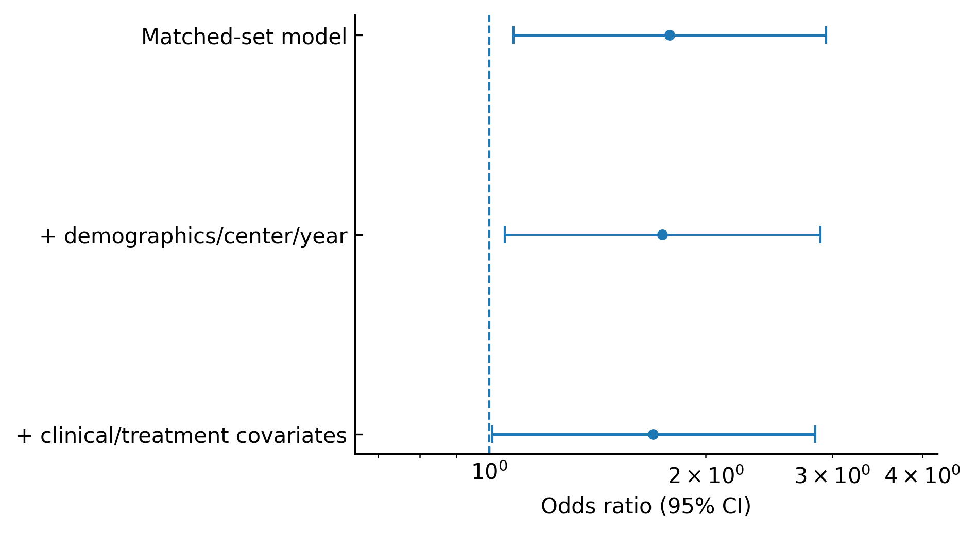
Supplementary Fig. 1. Forest plot of odds ratios for the primary composite endpoint across the prespecified matched-set logistic models. Error bars show 95% confidence intervals; the dashed reference line denotes OR = 1.0. CI, confidence interval.

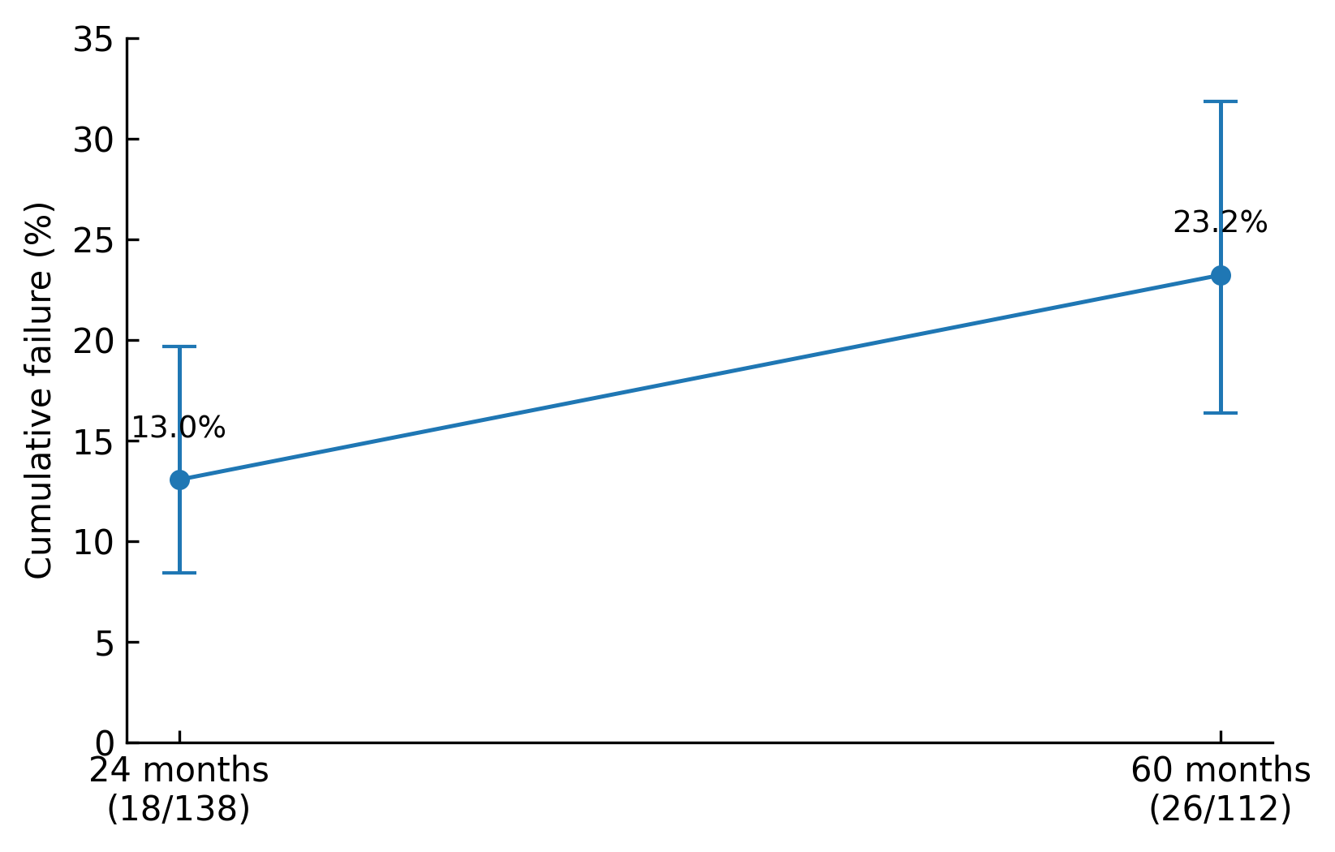
Supplementary Fig. 2. Pulpectomy failure at 24 and 60 months. Observed cumulative pulpectomy failure among evaluable teeth was 13.0% at 24 months (18/138; Wilson 95% CI 8.4–19.7%) and 23.2% at 60 months (26/112; Wilson 95% CI 16.4–31.8%). Censored teeth were not counted as failures.

Supplementary Table 2. Space loss and healthcare utilization outcomes.
Outcome | Extraction | Pulpectomy | Effect estimate | p value
Space loss >2 mm | 37.1% | 4.8% | ARD 32.3 percentage points (95% CI 23.6–41.0) | <0.001
Dental visits per tooth | 2 (IQR 1–3); n = 148 | 3 (IQR 2–4); n = 150 | — | <0.001
Direct dental charges, CNY | 1350 (IQR 900–2100); n = 142 | 1950 (IQR 1450–2700); n = 147 | — | <0.001
ARD is extraction minus pulpectomy. Utilization outcomes are summarized as median (IQR). ARD, absolute risk difference; CI, confidence interval; IQR, interquartile range; CNY, Chinese yuan.

Supplementary Table 3. Sensitivity and weighting analyses for the primary composite endpoint.
Analysis | OR (95% CI) | ARD, % (95% CI) | p value
Primary propensity score–matched analysis | 1.78 (1.08–2.94) | 12.0 (1.7–22.3) | 0.024
Retention restricted to pulpectomy only | 1.76 (1.06–2.91) | 11.8 (1.4–22.2) | 0.031
Retention with SSC subset | 2.05 (0.99–3.80) | 14.2 (0.8–27.6) | 0.052
Extraction with timely/high-adherence space maintenance | 1.45 (0.86–2.46) | 3.8 (−12.8–20.4) | 0.160
IPTW, full eligible cohort | 1.62 (1.10–2.62) | 9.7 (2.3–17.1) | 0.015
Overlap weighting, full eligible cohort | 1.58 (1.06–2.55) | 8.9 (1.6–16.2) | 0.021
OR compares extraction with pulpectomy. ARD is extraction minus pulpectomy. IPTW, inverse-probability-of-treatment weighting; SSC, stainless-steel crown; OR, odds ratio; ARD, absolute risk difference; CI, confidence interval.

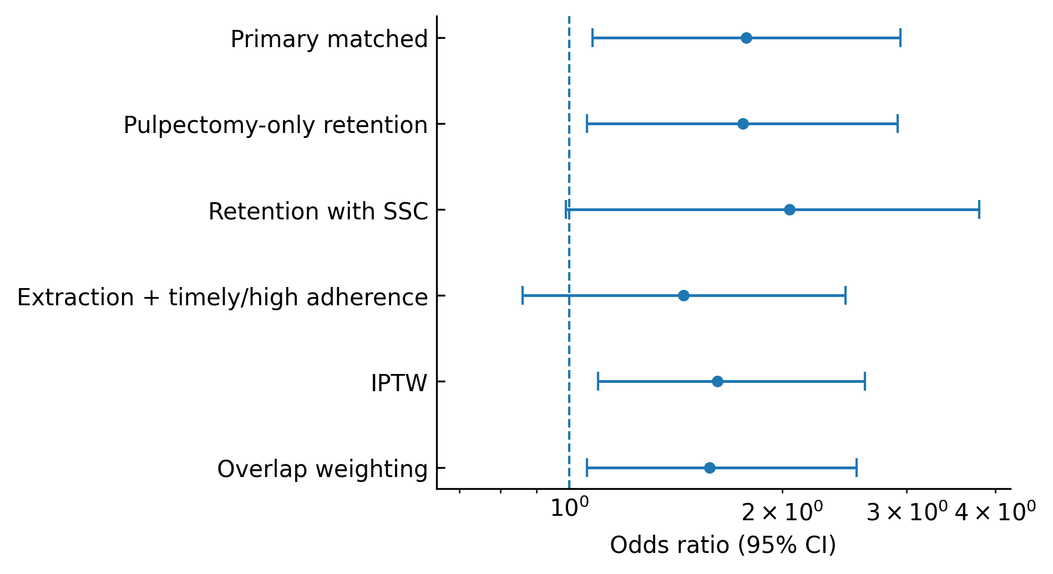
Supplementary Fig. 3. Forest plot of odds ratios across the primary, subgroup/restriction, and weighted robustness analyses. Error bars show 95% confidence intervals; the dashed reference line denotes OR = 1.0. IPTW, inverse-probability-of-treatment weighting; SSC, stainless-steel crown; CI, confidence interval.

